EXPERIMENT 1: DATA PREPROCESSING
AIM:
To preprocess a dataset by identifying missing values, filling missing numerical values with their mean, and standardizing numerical features using StandardScaler.
ALGORITHM:
- Import Pandas and StandardScaler.
- Load the dataset from data.csv.
- Display the first five rows of the dataset.
- Check for missing values in each column.
- Fill missing numerical values with their respective column means.
- Select the numerical columns Hours_Studied, Attendance, Assignments, and Marks.
- Apply StandardScaler to standardize the selected features.
- Convert the standardized data into a DataFrame.
- Display the first five rows of the normalized dataset.
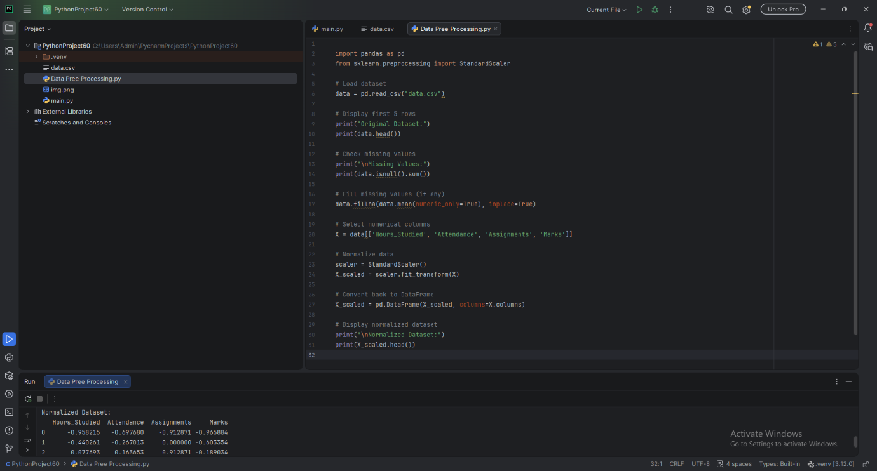
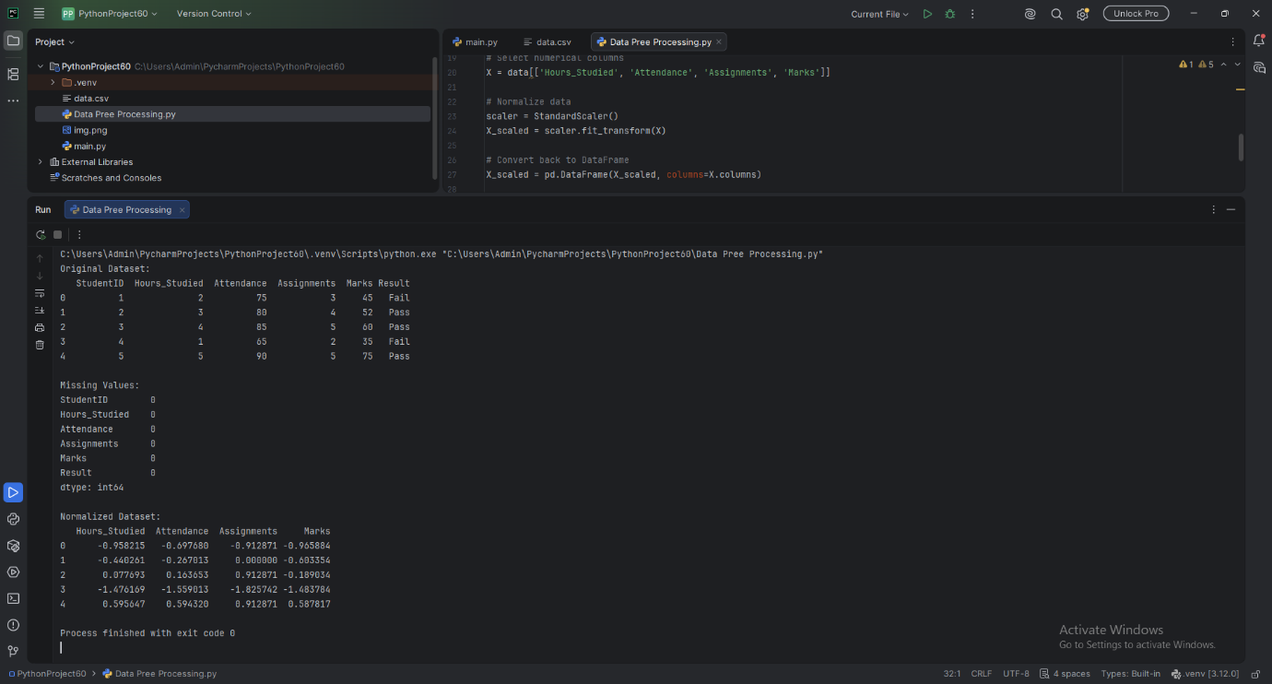

RESULT:
The dataset was successfully preprocessed by handling missing numerical values and standardizing the selected numerical features.

